1. NUnit-Handson

using NUnit.Framework;

using CalcLibrary; // Namespace of your actual code

namespace CalculatorLibrary.Tests

{

    [TestFixture]

    public class CalculatorTests

    {

        private SimpleCalculator calc;

        [SetUp]

        public void Setup()

        {

            calc = new SimpleCalculator();

        }

        [TearDown]

        public void TearDown()

        {

            calc.AllClear();

        }

        [TestCase(2, 3, 5)]

        [TestCase(10.5, 5.5, 16)]

        [TestCase(-1, -1, -2)]

        public void Test_Addition(double a, double b, double expected)

        {

            double result = calc.Addition(a, b);

            Assert.That(result, Is.EqualTo(expected));

        }

    }

}

OUTPUT:

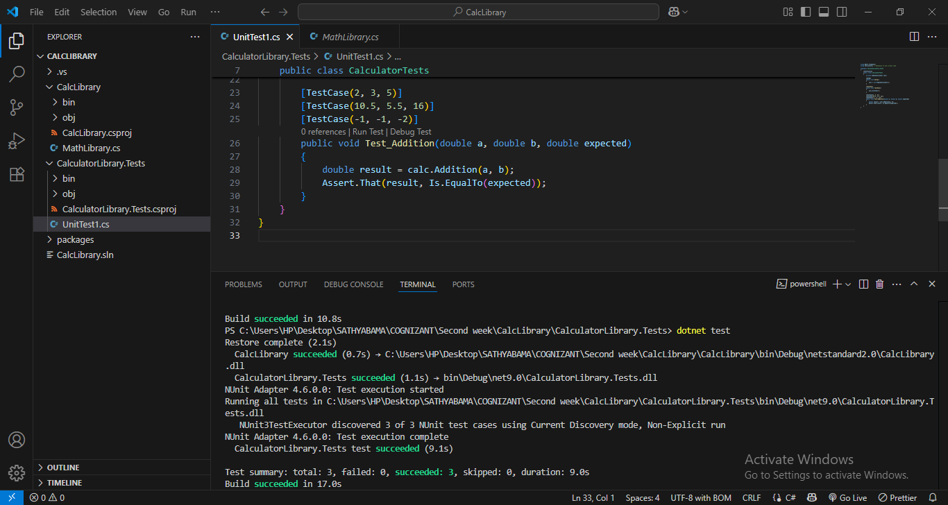

MailSender.cs

using System.Net;

using System.Net.Mail;

namespace MailServiceLib

{

    public interface IMailSender

    {

        bool SendMail(string toAddress, string message);

    }

    public class MailSender : IMailSender

    {

        public bool SendMail(string toAddress, string message)

        {

            MailMessage mail = new MailMessage();

            SmtpClient smtpServer = new SmtpClient("smtp.gmail.com");

            mail.From = new MailAddress("your_email@gmail.com");

            mail.To.Add(toAddress);

            mail.Subject = "Test Mail";

            mail.Body = message;

            smtpServer.Port = 587;

            smtpServer.Credentials = new NetworkCredential("username", "password");

            smtpServer.EnableSsl = true;

            smtpServer.Send(mail);

            return true;

        }

    }

}

CustomerComm.cs

namespace MailServiceLib

{

    public class CustomerComm

    {

        private readonly IMailSender _mailSender;

        public CustomerComm(IMailSender mailSender)

        {

            _mailSender = mailSender;

        }

        public bool SendMailToCustomer()

        {

            return _mailSender.SendMail("cust123@abc.com", "Some Message");

        }

    }

}

UnitTest1.cs

using NUnit.Framework;

using Moq;

using MailServiceLib;

namespace MailServiceLib.Tests

{

    public class CustomerCommTests

    {

        [Test]

        public void SendMailToCustomer_ShouldReturnTrue()

        {

            var mockMailSender = new Mock<IMailSender>();

            mockMailSender.Setup(x => x.SendMail(It.IsAny<string>(), It.IsAny<string>())).Returns(true);

            var customerComm = new CustomerComm(mockMailSender.Object);

            var result = customerComm.SendMailToCustomer();

            Assert.IsTrue(result);

        }

    }

}